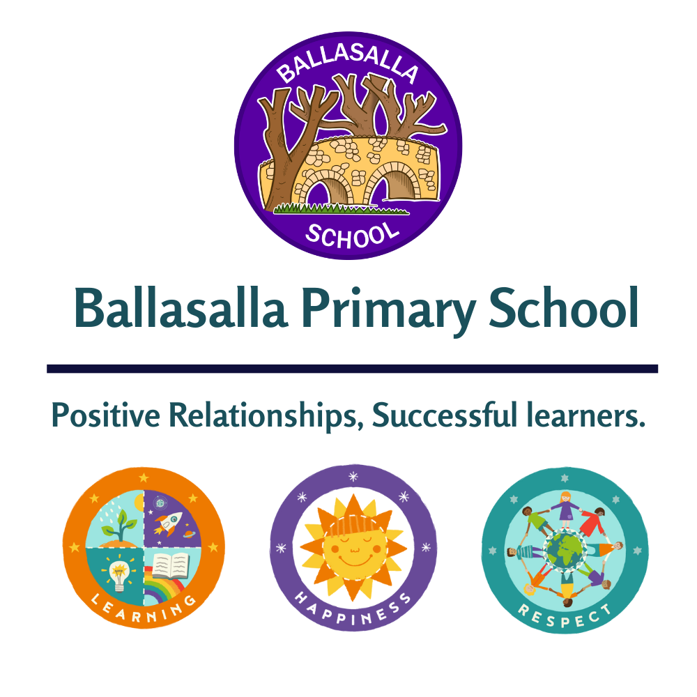

Sex and Relationship Education Policy
Ballasalla Primary School

March 2026
Glossary

Department means the Department of Education, Sport and Culture (DESC) including schools, UCM, Villa Gaiety and Manx Sport & Recreation.

DESC means Department of Education, Sport and Culture.

Drop Down Days are ‘off timetable’ days in which regular lessons are replaced by specialist sessions, often delivered by external professionals, to enhance PSHE provision.

Personal Development is a whole-school process which fosters pupils’ character, resilience, and well-being. It encompasses developing self-esteem, social skills, moral understanding, and preparing them for active citizenship and future success.

PSHE means Personal, Social, Health and Economic (PSHE) education.

RSE means Relationships and Sex Education.

Schools means any educational establishment maintained or provided by DESC.

Contents

Glossary 1
Summary 3
About this policy 3
Who is this document for? 3
Key points 3
Effective Date 3
Background Error! Bookmark not defined.
What is RSE? 4
Aims of RSE 4
The principles of high-quality RSE 5
Equality and Inclusion 5
Confidentiality and Safeguarding 6
The benefits of relationships and sex education 6
Overall school aims for RSE 7
Roles and responsibilities in school 8
Organisation and Delivery 11
Answering questions 11
Right of Withdrawal 12
External Agencies/Visitors 13
Associated Resources 15
Version Control 15
Review Date 15

Summary

About this policy
All children are entitled to Relationships and Sex Education (RSE). The UN Convention on the Rights of the Child, establishes that all young people have the same right to enjoy their sexuality within the highest attainable standard of health, free of coercion and violence, and to access quality sexuality education and sexual health services.
The Department of Education, Sport and Culture recognises the importance of high-quality, evidence-based, and developmentally appropriate Relationships and Sex Education (RSE) as an essential component of the schools’ curriculum to enable children and young people to make healthy choices, to keep themselves safe, physically and mentally well and to enjoy healthy relationships throughout their lives. RSE forms an integral strand of a broader PSHE education programme in schools to support pupils’ own wellbeing, their academic attainment and that of others.

To meet these expectations, DESC has worked with schools to produce a common framework, which this policy represents.

This document details Ballasalla School’s policy on the planning, organisation, and delivery of RSE within our setting.

Who is this document for?
This policy is for the leaders, staff and Governing Bodies of all the schools provided and maintained by DESC along with parents, pupils and the wider public.

Key points
- All pupils at Ballasalla School will receive RSE in accordance with this policy.
- Details of the RSE curriculum, including lesson content, will be made available to parents/carers via a centralised website Personal, Social and Health Eductation and/or our school website.
- Parents/carers have the right to withdraw their child from all or part of the RSE curriculum, and details of this process are outlined in this policy.

Effective Date
This document is effective from March 2026. It will be kept under review and updated at least annually.

What is RSE?
Relationships and Sex Education (RSE) is one component which falls under the wider Personal, Social, Health, and Economic (PSHE) education curriculum. RSE strives to offer children the information and skills needed to make informed choices, and to enjoy safe, healthy relationships throughout their lives. The attributes, skills, and knowledge gained from this learning will support the wellbeing and attainment of young people, and enables them to become successful, healthy adults who make meaningful and positive contributions to society.
At Ballasalla School we acknowledge that parents/carers are the primary educators of their children and a high-quality, school-based RSE curriculum can provide valuable support. Effective RSE:

- helps to protect children and young people
- enables them to keep themselves safe and well
- it can help to improve their physical, mental and social well-being.

The purpose of RSE is to provide opportunities for young people to explore themes related to the emotional, social, and physical elements of growing up, within a school culture which enables them to flourish. High-quality, evidence-based, and developmentally appropriate RSE is fundamental to support our young people’s readiness to live and thrive in a society that is becoming ever more dynamic and digitally advanced. It's about fostering a school culture in which children, young people, and adults can thrive. It's a commitment to developing the 'whole child' by equipping them with the attributes, skills, and knowledge that promote their well-being and that of the adults who work with and for them.

Aims of RSE
Developmentally appropriate RSE aims to:
- Help children and young people to understand and promote of their physical health;
- Improve children and young people’s emotional well-being and mental health;
- Safeguard children and young people by supporting them to stay safe online including an ability to report harmful behaviour;
- Inform children and young people of their rights and responsibilities in society, leading to greater community cohesion and appreciation of independence and interdependence within relationships
- Develop emotional intelligence and critical thinking skills, including around gender equity and power dynamics in relationships
- Reduce harmful behaviour, including sexual violence and relationship abuse, stigma and discrimination
- Help children and young people to develop positive relationships with themselves and others, based on respect and equality
- Compliments and supports parental guidance

The principles of high-quality RSE
RSE inBallasalla School:
- is a partnership between home and school
- ensures pupils’ views are actively sought to influence lesson planning and teaching
- starts early and is relevant to pupils at each stage in their development and maturity
- is taught by people who are trained and confident in talking about issues such as healthy relationships but also abuse, consent, equality, gender stereotypes, pleasure, respect, sex and sexuality
- includes the acquisition of knowledge, the development of life skills and respectful attitudes and values, and personal attributes
- has sufficient time to cover a wide range of topics, with a strong emphasis on relationships, consent, rights, responsibilities to others, negotiation and communication skills, and accessing services
- helps pupils understand on and offline safety, harassment, violence and exploitation
- is both medically and factually correct and treats sex as a normal and pleasurable fact of life for adults
- is inclusive of differences such as: age, ethnicity, culture, faith or belief, gender identity, sexual orientation, special educational needs and disability, or other life experience
- uses active learning methods and is rigorously planned, assessed and evaluated
- helps pupils understand a range of views and beliefs about relationships and sex in society, which may differ from their own
- teaches pupils about the law and their rights to confidentiality, and is linked to school-based and community health services and organisations
- teaches pupils about the legal age of consent for sex, and that young people under this age may still access free, confidential services before the age of 16.
- promotes equality in relationships, recognises and challenges gender inequality and reflects girls’ and boys’ different experiences and needs

Equality and Inclusion
Ballasalla School strives to provide a RSE curriculum in a manner which meets the needs of all the children and young people in our diverse learning community. We aim to create an environment which is safe and accessible for all our learners, in which all pupils including those with special educational needs and/or disabilities, feel valued, respected, and represented.
We believe that all pupils have the right to high-quality RSE regardless of age, sex, race, disability, religion or belief, gender reassignment, pregnancy or maternity, marriage or civil partnership, or sexual orientation (collectively known as the ‘protected characteristics’ under the Isle of Man Equality Act 2017 Equality in education).
As with all pupils, RSE for pupils with SEN should be part of life-long learning and begin at reception/school entry and continue throughout formal education and beyond. Starting with core concepts such as public and private, using correct terms for private parts of the body, an understanding of rights relating to our bodies, rules relating to touch, positive friendships, respect and consent.
For pupils with SEN, this means working continuously through informal opportunities as well as the formal RSE curriculum. For example, when pupils are queuing for lunch there is an opportunity to reinforce learning about personal boundaries. All staff should be actively involved in offering consistent messages around RSE.
Pupils with SEN in mainstream schools may need additional support to make sense of RSE lessons. Sometimes, separate small group sessions or individual work can help, especially since aspects of their maturity may lag behind their peers. It may be appropriate to offer additional small group sessions for pupils with SEN that allow for questions and discussions that might be challenging or increase the risk of bullying in a usual class format.

Confidentiality and Safeguarding
One of the primary aims of RSE is to promote well-being and safeguard children and young people.
When teaching RSE, the aim is to strike a balance between helping pupils to feel respected, safe, and able to participate fully and openly while still protecting privacy and safeguarding welfare. Effective teaching and learning in RSE actively encourages pupils to share thoughts and voice opinions, so it is important to establish boundaries and clarify at the outset with pupils what will happen to any personal information they might disclose in the classroom.
Adults need to be aware that effective RSE, which brings an understanding of what is and is not acceptable in a relationship, may lead to disclosure of safeguarding issues. All staff, no matter what their role within Ballasalla School, have a good working knowledge and know how to follow the school’s confidentiality and safeguarding policies.
Concerns about confidentiality and subsequent lack of trust are frequent barriers that stop young people from accessing sexual health advice and treatment. All young people, including those aged under 16, are entitled to confidential sexual health and contraceptive advice and treatment. Improving access to confidential sexual health services, is one of the ways in which schools may help their pupils to stay safe and avoid health outcomes that have a negative impact.

The benefits of relationships and sex education
There is no evidence that RSE encourages young people to have sex earlier. In fact, high-quality RSE offers numerous benefits for young people, fostering healthier and safer transitions into adulthood. Programmes are consistently linked to increased knowledge about sexual and reproductive health, including contraception and sexually transmitted infections (STIs). This enhanced understanding empowers young people to make informed decisions about their bodies and relationships.
Research indicates that comprehensive RSE does not lead to earlier sexual debut but promotes safer sexual practices when young people do become sexually active (UNESCO, 2009).
Beyond physical health, comprehensive RSE contributes to improved emotional well-being by addressing topics like consent, healthy relationships, gender equality, and communication skills. This holistic approach reduces the incidence of risky behaviours, unintended pregnancies, and STIs, while also empowering young people to recognise and prevent sexual violence and abuse.

Overall school aims for RSE
The Ballasalla School approach to RSE consists of a comprehensive and developmental teaching and learning programme, where the health and well-being of pupils and the whole school community are actively promoted.
Our RSE programme has a positive influence on the ethos, learning and relationships throughout the school. It is central to our values and to achieving our school’s stated aims and objectives.
Our RSE programme helps pupils to develop the knowledge, understanding, skills and attitudes they need to live confident, healthy, independent lives now and in the future.
Through the provision outlined in this policy, the school’s overall aims of RSE are to teach and develop the following three main elements:
Attributes and values:
- learn the importance of values and individual conscience and moral considerations
- learn the value of family life, marriage, and stable and loving relationships for the nurture of children
- learn the value of respect, love and care
- explore, consider and understand moral dilemmas
- develop critical thinking as part of decision-making
Our RSE provision also aims to help pupils develop respect for self and others, a sense of self-worth, honesty and courage and believe they can persevere and work towards long-term rewards, despite setbacks, to achieve. We also aim to develop pupils’ humility, kindness, generosity, trustworthiness and a sense of social justice.
Personal and social skills:
- learn to manage emotions and relationships confidently and sensitively
- develop self-respect and empathy for others
- learn to make choices based on an understanding of difference and with an absence of prejudice
- develop an appreciation of the consequences of choices made
- manage conflict
- learn how to recognise and avoid exploitation and abuse
Knowledge and understanding:
- learn and understand physical development at appropriate stages
- understand human reproduction, sexual health, emotions and relationships.

Roles and responsibilities in school
The Headteacher is responsible for ensuring that RSE is taught consistently across Ballasalla School and for managing requests to withdraw pupils from RSE.
The table below outlines the staff members that undertake specific responsibilities relating to RSE at Ballasalla School.
Specific responsibilities | Staff
Coordinating the RSE Provision, ensuring a spiral curriculum | Nic Moorcroft
Accessing and coordinating training and support for staff | Nic Moorcroft
Policy development and review, including consultation and dissemination | Nic Moorcroft
Implementation of the policy; monitoring and assessing its effectiveness and practice | Nic Moorcroft
Link Governor RSE | Nic Moorcroft
Managing child protection/safeguarding issues | Jamie Cox & Nic Moorcroft
Establishing and maintaining links with parents/carers | All staff

All staff will:

- Ensure that they are up to date with school policy and curriculum requirements regarding RSE
- attend and engage in professional development training around RSE provision, including individual and whole staff training/inset, where appropriate
- Attend staff meetings to be introduced to any new areas of work and review the effectiveness of the approaches used
- Report to the PSHE lead on any areas that they feel are not covered or inadequately provided for in the school’s RSE provision, including resources
- Encourage pupils to communicate concerns regarding their social, personal and emotional development in confidence and listen to their needs and support them
- Follow the school’s reporting systems if a pupil comes to a member of staff with an issue that they feel they are not able to deal with alone
- Ensure that their personal beliefs and attitudes do not prevent them from providing a balanced approach to RSE in school
- Tailor their lessons to suit all pupils in their class, across the whole range of abilities, faiths, beliefs, culture, gender identity and sexual orientations, including SEN
- Ask for support in this from the school SEN coordinator, the designated lead for mental health, the designated safeguarding lead or the PSHE Lead, should they need it

Lead member(s) of staff

The lead member(s) of staff will receive training in their role and responsibilities. This supports them to lead on the development of the school’s policy and practice and to monitor its implementation. This practice includes the curriculum and approaches to teaching and learning, as well as whole-school approaches to health and wellbeing.

The lead member(s) of staff will:

- develop the school policy and review it annually and work with governors to update this policy as appropriate.
- ensure all members of the governing body are offered appropriate RSE training
- ensure that all staff are given regular and ongoing training on issues relating to RSE as well as how to deliver lessons on such issues
- ensure that all staff are up to date with policy changes, and familiar with school policy and guidance relating to RSE, including new staff or supply staff
- provide support to staff members who feel uncomfortable or ill-equipped to deal with the delivery of RSE to pupils
- ensure that RSE is age-appropriate and needs-led across all year groups; this means ensuring that the curriculum develops as the pupils do and meets their needs
- ensure that the knowledge and information regarding RSE to which all pupils are entitled is provided in a comprehensive way
- support parent/carer involvement in the development of the RSE curriculum
- ensure that their personal beliefs, values and attitudes will not prevent them from providing a balanced approach to RSE in school
- ccommunicate freely with staff, parents/carers and the governing body to ensure that everyone is in understanding of the school policy and curriculum for RSE, and that any concerns or opinions regarding the provision at the school are listened to, taken into account and acted on as appropriate
- share the school’s provision for RSE with parents/carers in order to ensure they can support this at home
- communicate to parents/carers any additional support that is available from the school to support them with RSE at home.

Governors

The governing body as a whole plays an active role in monitoring, developing and reviewing the policy and its implementation in school. The named link governor for RSE at Ballasalla School is Nic Moorcroft who works closely with, and in support of, the lead member(s) of staff.

When aspects of RSE appear in the School Improvement Plan, a governor will be assigned to reflect on, monitor and review the work as appropriate. The governing body will also make sure that:
- all pupils make progress in achieving the expected educational outcomes
- RSE is well led, effectively managed and well planned;
- the quality of provision is subject to regular and effective self-evaluation;
- teaching is delivered in ways that are accessible to all pupils with SEND;
- clear information is provided for parents on the subject content and the right to request that their child is withdrawn from RSE as appropriate
- the subject is resourced, staffed and timetabled in a way that ensures that the school can fulfil local expectations

All pupils:

- should support one another with issues that arise through RSE by, for example, alerting relevant members of staff to any potential worries or issues
- will listen in class, be considerate of other people’s feelings and beliefs and comply with the ground rules that are expected
- will have the opportunity to talk to a member of staff, in confidence, regarding any concerns they have in school related to RSE or otherwise
- will be asked for feedback on the school’s RSE provision (e.g. through questionnaires and/or school council meetings) and be expected to take this responsibility seriously; opinions on provision and comments will be reviewed by the lead member(s) of staff for RSE and taken into consideration when the curriculum is prepared for the following year’s pupils

Parents/carers

The role of parents in developing their children’s understanding of relationships is vital. Parents are the first teachers of their children. They have the most significant influence in enabling their children to grow and mature and to form healthy relationships.

Parents are expected to support the school's values and ethos and take an interest in their child’s RSE. When parents have any questions or concerns about any aspect of their child's education, including RSE, we expect them to approach the school with the same levels of respect and politeness that they would expect in return.

The school will:

- communicate with parents/carers know what will be taught and when, and communicate the fact that parents have the right to request that their child be withdrawn from some or all of RSE
- give parents/carers every opportunity to understand the purpose and content of RSE
- communicate and give opportunities for parents/carers to understand and ask questions about the school’s approach help increase confidence in the curriculum
- build a good relationship with parents/carers on these subjects over time by inviting parents into school to discuss what will be taught, address any concerns and help support them in managing conversations with their children on these issues
- encourage parents/carers to create an open home environment where pupils can engage, discuss and continue to learn about matters that have been raised through RSE

Staff Support

It is important that all staff feel comfortable to deliver RSE lessons. The school provides regular professional development training in how to deliver RSE. Staff (including non-teaching staff) Continous Professional Development (CPD) needs are identified and met through the following ways:
- training and support organised by Nic Moorcroft who may choose to liaise with external agencies.
- staff will be offered generic RSE training which includes sessions on topics including, but not restricted to:
  - confidentiality
  - creating ground rules
  - handling controversial issues
  - responding to awkward questions
  - an introduction to the rationale of why teaching RSE is so important
  - current law and guidance
  - learning outcomes
  - school policy
- staff involved in the delivery of issues seen as potentially more sensitive will be offered appropriate training to encourage confidence in dealing with matters of confidentiality, child protection, sensitive issues and potentially difficult questions
- DESC will support in meeting staff CPD needs and giving advice when requested

Organisation and Delivery
Schools need to describe here:
- RSE is taught by class teachers as part of their regular timetable
- RSE is considered part of our PSHE curriculum and also fits within our science curriculum
- Lesson content is housed on the DESC website

Answering questions
We acknowledge that potentially sensitive or controversial issues will arise as pupils will naturally share information and ask questions.
They will often ask teachers or other adults questions pertaining to sex, sexuality and relationships which go beyond the RSE curriculum.
We also acknowledge that children of the same age may be developmentally at different stages leading to differing types of questions or behaviours.
When spontaneous discussions arise, it is guided in a way that reflects the school aims and values and curriculum content for RSE.
As a first principle, we answer questions relating to taught, planned curriculum for that age group to the whole class. We answer questions, where appropriate, relating to areas beyond the taught, planned curriculum for that age group, in a sensitive and age-appropriate way, only to the pupil or pupils who have asked the question.
If a member of staff is uncertain about the answer to a question, or indeed whether they should answer it, they will seek guidance from the RSE lead / Designated Safeguarding Lead or their deputies.
Questions may be referred to parents/carers if it is not appropriate to answer them in school. We may also use a question box where questions may be asked anonymously and teachers will address these appropriately within class.
When answering questions we ensure that sharing personal information by adults, pupils or their families is discouraged.
Where a question or comment from a pupil in the classroom indicates the possibilities of abuse or risk of harm, teachers will pass this information to the Designated Safeguarding Lead, in line with school policy and procedures.
Staff training will include sessions on how to deal with difficult questions.
Agreed phrases, where appropriate, will be used in response to difficult questions. Phrases we will use include (but are not limited to): ‘I can only answer question on the content of this lesson’ or ‘That is something that may be covered later on’ or ‘I can’t answer that question, but you could ask your parents/carers’.
Ground rules are essential when discussing sensitive subject matters. Staff will establish clear parameters about what is appropriate and inappropriate in a whole-class setting by for example:
- Staff will set the tone by speaking in a matter-of-fact way
- Pupils will be encouraged to write down questions anonymously if desired and post them in a question box or ask-it basket
- Staff will have time to prepare answers to all questions before the next session and will choose not to respond in a whole-class setting to any questions that are inappropriate or need one-to-one follow-up
- If a verbal question is too personal, staff will remind the pupils of the ground rules. Staff may respond with phrases like “That’s a personal question about my private life, and I don’t talk about that in class”
- If a question is too explicit, feels too old for a pupil, is inappropriate for the whole class, or raises concerns, staff will acknowledge it and promise to attend to it later on an individual basis
- Staff will not provide more information than is appropriate for the pupil’s age and developmental level
- If staff are concerned that a pupil is at risk of abuse, the designated teacher will be informed, and the usual safeguarding procedures will be followed

Right of Withdrawal
At Ballasalla School, we believe in the importance of RSE and its role in equipping children and young people with the skills and knowledge they need to stay safe and well, and to form healthy relationships as they grow. We also understand that decisions regarding a child’s education are personal and often reflect individual family values and beliefs. We appreciate that some parents/carers may have questions or concerns about what is being taught.
Further information about the RSE Advisory curriculum is available for parents/carers and can be found on the Department’s website (linked here - Relationships and Sex Education Advisory Curriculum).
Parents/carers can withdraw their child from any aspect of RSE, although we believe it is essential that all children receive this content, which covers topics such as friendships, staying safe, and puberty.
RSE is a vital part of the school curriculum and supports child development, and we strongly advise parents/carers to carefully consider their decision before withdrawing their child from this aspect of school life. We acknowledge, however, that the final decision is for the parents/carers to take, and the child and family will not be stigmatised for the decision.
While we respect this right, we would also welcome the opportunity to discuss any concerns a parent/carer may have, prior to choosing to withdraw their child.
If parents/carers do have concerns about the content of any lessons, we respectfully ask them to liaise directly with the school.
Should a parent/carer wish to discuss the RSE curriculum, the following process should be followed:
- Requests for withdrawal should be in writing and addressed to the headteacher.
- Before granting any such wish, school staff will discuss this request with parents/carers and, as appropriate, with the child to ensure that their wishes are understood and to clarify the nature and purpose of the curriculum.
- This process will be documented to ensure a record is kept.
- The school staff will also discuss with parents/carers the benefits of receiving this important education and any detrimental effects that withdrawal might have on the child. This will include any social and emotional effects of being excluded, as well as the likelihood that the child will hear their peers’ version of what was said in class, rather than what was directly stated by the teacher.
The school will arrange for pupils withdrawn from RSE to be provided with an educationally valid alternative for the duration of the lesson.

External Agencies/Visitors
The RSE curriculum in our school is enriched by the involvement of external agencies, who offer additional input and resources to support curriculum delivery. Agencies may be invited to deliver specific lessons as part of a scheduled drop-down day, or as a response to an identified need within our school.
Examples of agencies we may work with include:
- Isle of Man Constabulary
- Isle of Man Prison Service
- Motiv8
- Isle Listen
- St John’s Ambulance
- Kensington Arts (Culture Division of DESC)

All visitors to school premises must abide by the Department’s Visitor Policy which can be found here visitors-policy-for-ucm-and-schools-v10.pdf

Associated Resources

UK Government Department for Education, Relationships and sex education (RSE) and health education: Relationships and sex education (RSE) and health education - GOV.UK

Sex Education Forum: https://www.sexeducationforum.org.uk/

PSHE Association: https://pshe-association.org.uk/

UNESCO (United Nations Educational, Scientific and Cultural Organization): International technical guidance on sexuality education: an evidence-informed approach; overview - UNESCO Digital Library

World Health Organization (WHO): Comprehensive sexuality education

Version Control

This is the RSE Policy of Ballasalla School

Version | Author | Date | Changes
V0.1 | DESC | August 2025 | Template provided
V0.2 | Nic Moorcroft | March 2026 | School branding and local arrangements added.

Review Date

This document was issued on 9.3.26 and is due to be reviewed annually.

RSE The Evidence - two page summary.pdf

